Points were deducted because the output did not match the requirements and the randomNumber variable was not properly defined. The correct solution is below:

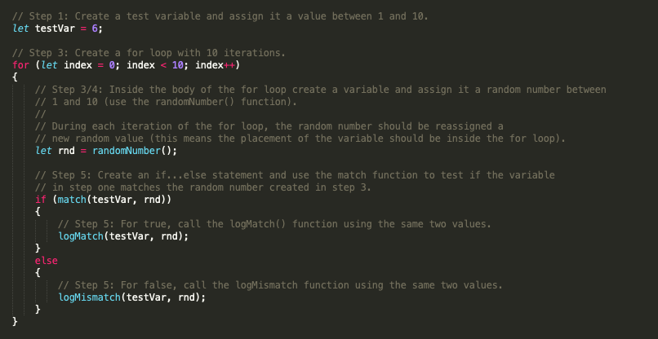

Otherwise, great use of code comments and indention!